**Do you want to beat AI on map reading?**

**Needed: adults (age 18+) to participate in choropleth map reading research**

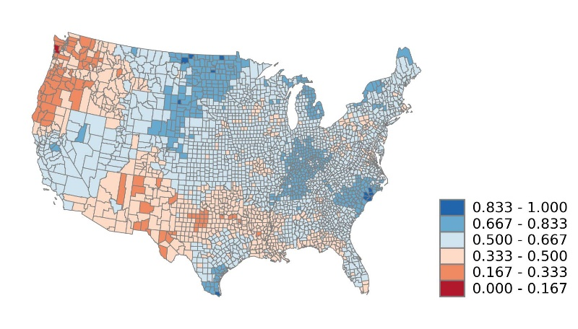

We are looking for volunteers of age 18 and over to participate in a survey about reading maps. The goal of this study is to explore how well artificial intelligence (AI) algorithms can compare with humans in identifying spatial patterns in a specific type of maps: choropleth maps. An example of choropleth maps in our survey is shown above. Choropleth maps are used to display the spatial distribution of quantitative data across the enumeration units such as counties and states in a region. The survey will be used to collect data to measure the performance of humans (you) on reading spatial patterns shown on the maps, which will be compared with computers equipped with AI techniques in our further analysis.

More specifically, you will be presented choropleth maps with different spatial patterns. You will be asked to answer two simple questions about spatial concentration and correlation for each choropleth maps. You need to answer the questions based on what you read and learn from the mapped area.

All the questions together take about 20 minutes to complete. It is EASY and QUICK to prove your capability over **AI**! Participation in this study is strictly voluntary. We will NOT collect your personal information. All data collected will be anonymous.

If you are interested, please contact PI, Dr. Ningchuan Xiao (xiao.37@osu.edu) or the Co-Investigator, Mr. Jialin Li (li.7957@osu.edu) for more information.

(Image source: [Towardsai](https://towardsai.net/p/artificial-intelligence/understanding-artificial-intelligence))